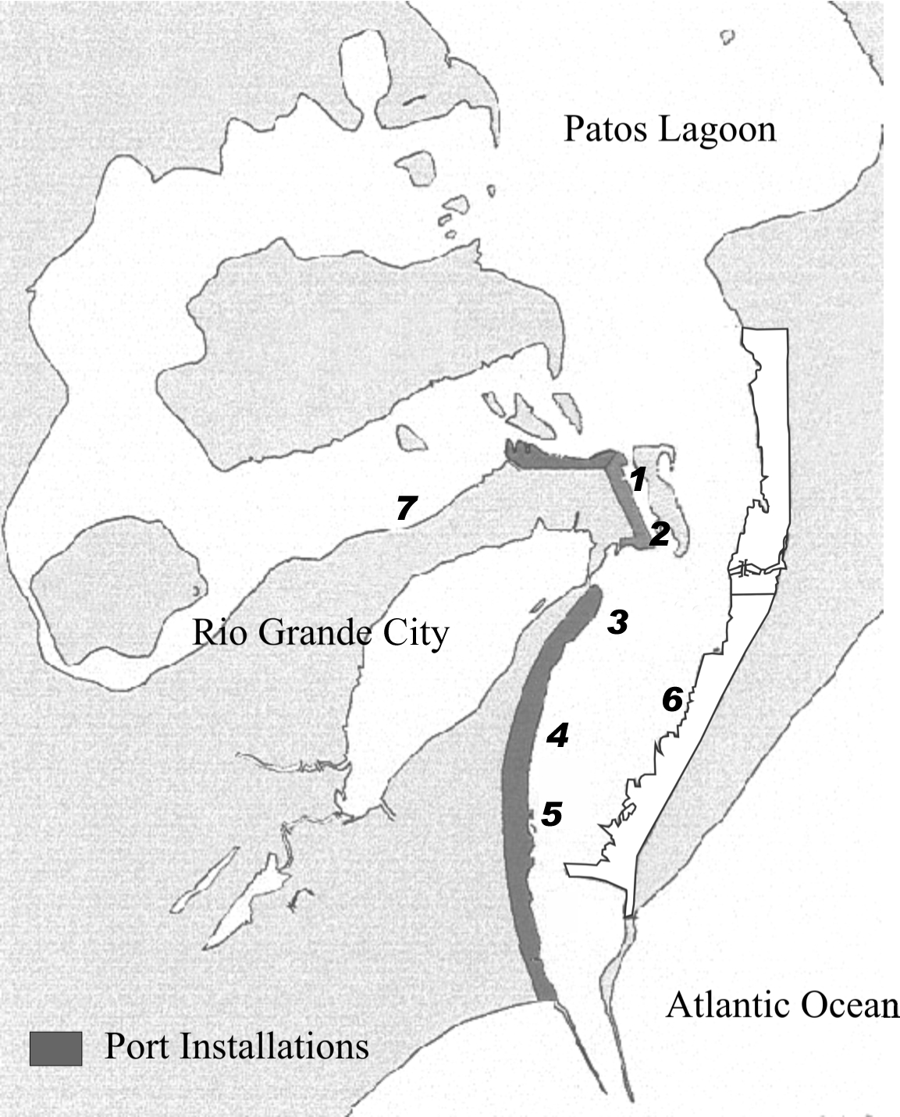
Figure 1. Stations location: 1 solid grain depot; 2 roll on-roll off pier; 3 oil terminal; 4 grain terminal; 5 container terminal; 6 ferry-boat dock; 7 urban.

