Supplemental Material

Environmental perception and activities in environmental education based on socio-ecological resilience
SUPPLEMENTAL MATERIAL

Environmental perception and activities in environmental education based on the concept of socio-ecological resilience

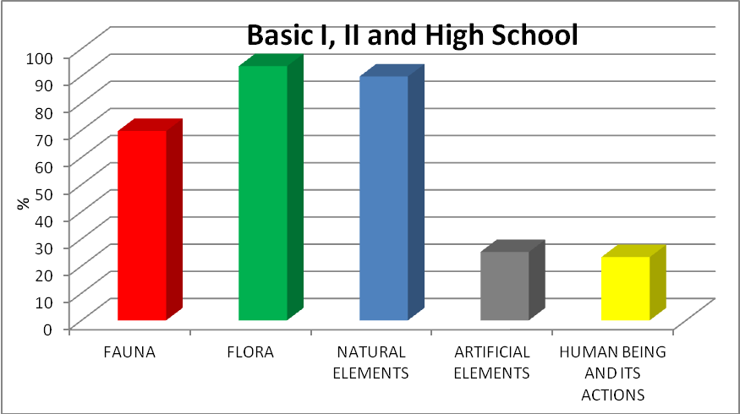
Figure S1. The components of environment according to the students of the basic level.
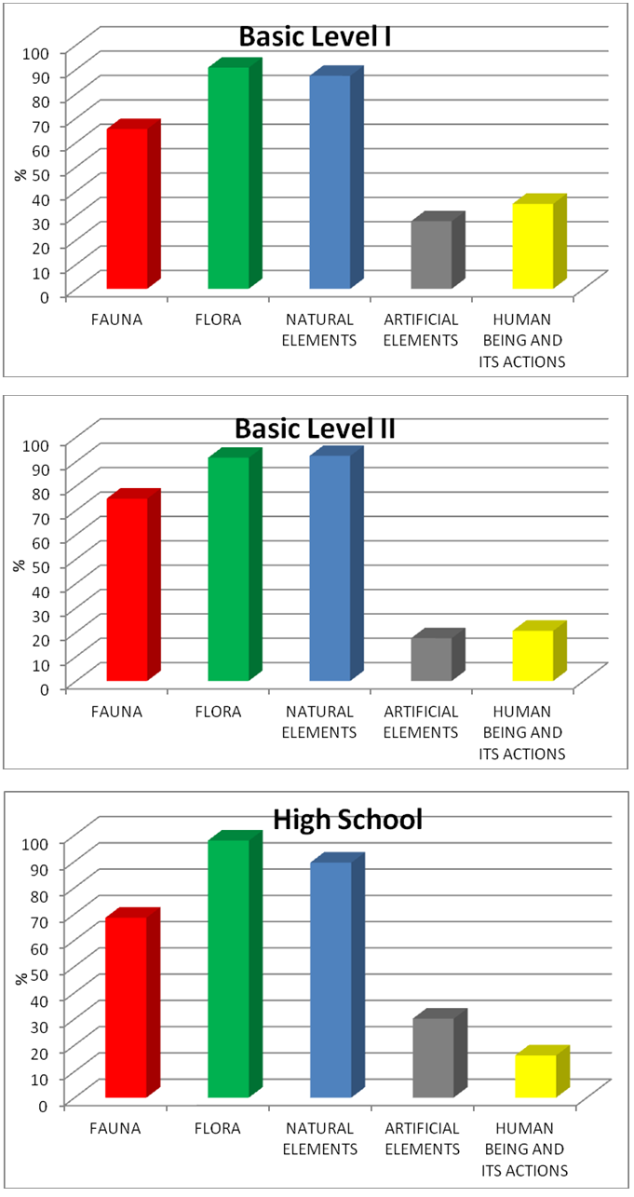
Figure S2. The components of environment according to the students of the basic level, by segment.
Methodological proposal for teaching
The teaching-learning process must be meaningful, that is, the mental structures should be changed with new information and perceptive stimuli, in order to obtain a mental rearrangement of information, contents and conceptions. This allows the construction of knowledge and, consequently, the ability to transfer this knowledge to other situations, modifying thinking patterns and actions. For the environmental knowledge, this construction should favour the establishment of concepts about sustainability, environmental complexity, adaptability and socio-ecological resilience.
The educators developing activities and projects in environmental education should have freedom to choose the contents and to make adaptations according to the specificity of the target public, but a methodological instrument to support the teaching planning is necessary. Obviously, this requires support from the educational institution. The lack of a theoretical scheme to support the planning of environmental themes can cause the development of non-effective activities, either due to the suppression of the cognition capacity of students, their previous knowledge or to the development of disconnected and old contents, which are not included in the students' context and, therefore, are not of interest.
Because of some methodological scarcity about this theme, the following organizing scheme is proposed for the environmental reasoning (Scheme 1).
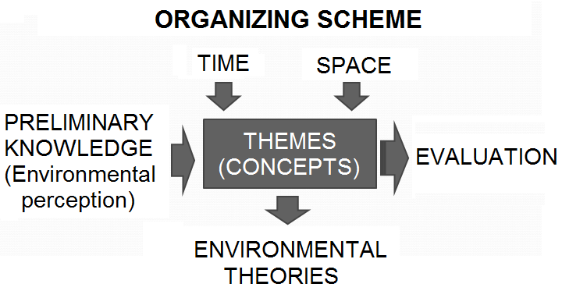
Scheme 1. Organization of the environmental reasoning.

The proposed scheme is a planning instrument and can be adapted for any learning level of formal education. The educator can plan diverse moments of learning using this scheme, by means of content collection, analysis and evaluation. The main learning moments in environmental education are: evaluating previous knowledge, development of environmental concepts and contents and the process of learning evaluation.
The project planning in environmental education should establish the research objectives , as well as the target public. The themes should be chosen and the disciplines, activity formats as well as the probable number of lectures should be defined. Before developing the proposed theme, it is necessary to identify which environmental knowledge is experienced by the public target, in order to plan the next step, the development of concepts and contents.
We indicate environmental perception methods to probe the environmental knowledge, while the data collection should be performed using structured, non-structured and mixed questionnaires, as well as mental maps, interviews, photo and iconographic analysis. The data should be analysed using content analysis (to capture and categorise textual information) and descriptive statistics (to organise and obtain numerical insight about the textual outcomes). With the previous knowledge available, it is possible to establish adaptations in the teaching activities, as well as to include/exclude contents and to make them deeper.
Despite a variety of factors, such as personal moral aspects, the concepts and contents in environmental education tend to influence someone to change degradation processes towards conservationist actions. However, if they are inadequately developed, without considering the previous knowledge of the target public, or even the peculiarities of the place where this public lives, as well as the chronology of environmental events and time for learning of the group, the results can frustrate the involved parts. In the scheme above, the time variable refers to the fitting of the language to the chronological and cognitive age of the target public and, consequently, to the fitting of the content to the local and planetary environmental events. The space variable refers to the fitting of activities in the geographical space where they will be developed, as well as their link with the world (local/global relationship).
The environmental concepts and contents should be worked on from a starting theme. The themes allow ranking and integrating the contents and facilitate the update and recycling of the environmental knowledge using researches in this field. The themes should be supported by environmental concepts and theories, as well as by the didactic theories that the educator and school share. The lectures should mobilize the mental operations of the target public, i.e. they should be operative. In an operative lecture, mental operations like synthesis, knowledge transfer, comparison, analysis, summation, etc. should be present to unchain the process of building the knowledge.
In order to investigate if a given content was learned and, consequently, to plan the following step of the learning process, evaluation activities should be applied, such as written or oral tests, presentation of seminars, preparation of conceptual maps, dramatization, debates, organization of awareness programs, etc. The evaluation should be operative, that is, it should be consistent with the lecture and mobilize the mental operations about the contents, in order to include the developed reasoning.
The teaching activities should be consistent with the objectives of the environmental education, which is to educate an environmental citizen able to think and act according to a sustainable and resilient way. It is worth mentioning that an educator should evaluate if the proposed abilities have been developed efficiently during the activities. Examples of abilities to be developed in environmental education are: analysis of maps, identification of environmental impacts, identification of elements composing the environment, etc. The diagnostics of competences (wider than abilities) should also appear during the development of activities. Examples of competences in environmental education are: reasoning of historical-spatial reconstruction, capacity to judge the conservationism of actions, identification and comprehension of the causes and consequences of environmental impacts, etc. The reasoning abilities and competences contribute to the development of the socio-ecological resilience and, consequently, to the effective conservation of the socio-ecological system.

Proposal of a project in environmental education
A project in environmental education is proposed based on the scheme in Figure 3, containing the generator theme, the probing of previous knowledge, the environmental concepts and contents, the adequacy of the time and space, the evaluation process, the teaching strategies, the methods to develop the activities, and expected abilities and competences. It is important to mention that this purpose is a methodological example; it depends on the educator to adapt the activity to any degree of the formal education, as well as to the objectives and specificities of the target public. The teaching process can follow either an interactive or didactic approach, but both methods should be integrative in such a way that there is knowledge exchange among the group components (students and teacher). We describe a didactic approach (with interactive participation) in the next section to balance the knowledge among the group components before an interactive fieldwork.

Project in environmental education
Modality: Formal environmental education.
Theme: Socio-ecological system.
Objective: To construct the concept of the environment with the target public from the theories of socio-ecological system and environmental complexity, undoing incoherent social representations (personal epistemological beliefs, PEBs) and stimulating environmental conservation.
Target public: 11-12 years old students.
Correlate disciplines: Sciences and Geography.
Duration: 12 lectures of 50 minutes each.
Main concept of the activity: The Environment.
Proposed contents: different definitions of the environment; concept of the environment; socio-ecological system; environmental complexity of the school; correct and incorrect actions for the environment.
Evaluation activities: diverse, with a final conclusion at the end of each activity.
Teaching strategy: didactic lecture; study of the surrounding environment; group discussion (interactive approach).
Didactical resources: conceptual map; annotation at work; data organization in tables; production of texts and mock-up interpretation.

The teaching activity can be developed using the following steps:

STEP 1: Evaluating preliminary knowledge about environment.
Lecture objective: to identify the environmental conceptions of the students and diagnose the elements composing the environment, according to the students, as well as their PEBs.
Duration: 1 lecture (50 minutes).
Development: Administer or provide a questionnaire to each student with the following question: 'Draw what the environment is to you'. The questionnaire must contain the student's name (duration: about 15 minutes).
Afterwards, the educator should collect the questionnaires and initiate an interactive debate. The educator should show that there are many elements that compose the environment and that these elements interact and have relationships. The principles of the environmental impact and its consequences should be introduced, instigating students to indicate the maximum possible amount of elements, relationships and phenomena in an environment organized as a network. The discussion should be culminated with examples describing complex and reductionist definitions about the environment, i.e. those including the human being and his actions and those that ignore them (duration: about 10 minutes).
Another questionnaire should be delivered, asking students to carry out another drawing about environment (duration: 15 minutes). Afterwards, the first questionnaire should be returned to the students and they should verify the scores obtained in both questionnaires, according to: flora elements = 1 point; fauna elements = 1 point; other natural elements = 1 point; artificial elements = 1 point; human being and his actions = 2 points (duration: about 5 minutes).
Evaluation activity: Discuss the numerical difference between the results of the two questionnaires, leading students to understand the variety of elements that can be considered in the environment concept (duration: about 5 minutes).
Finally, the educator should collect all questionnaires to diagnose the students' definitions of the environment in order to plan the next step, paying greater attention to the PEBs that should either be stressed or altered.

STEP 2: Construction of the concept of the environment.
Objective: to build, together with students, the concept of the environment using the socio-ecological system framework, and indicate the importance of the human being as the main intervener of the system.
Duration: 2 lectures of 50 minutes each.
Development: The lecture should be expositive (to balance the knowledge) about the socio-ecological system, its components, phenomena and processes. It should be supported with a mock-up containing irregular relief, hydrography, forestry, cropping field and urban area. This should make the discussion more concrete and didactical (duration: about 60 minutes).
The contents to be studied include:
- How to organize a system;
- The components of a socio-ecological system;
- The interrelationships and environmental interactions (the life web).
A reasoning scheme to synthesize and fix the theory should be built with students (duration: about 25 minutes). The scheme should be similar to (Scheme 2):
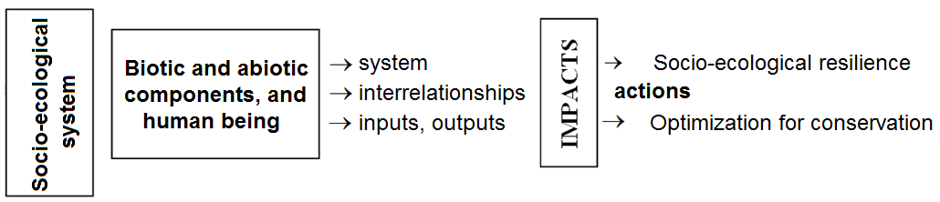
Scheme 2. Reasoning about socio-ecological system.

After the theoretical foundation, an appropriate concept for the environment or socio-ecological system should be drafted according something like:
- The Environment is a system comprising biotic and abiotic elements with constant interaction. The human being is its main intervener component who dynamises and modifies a set of actions of natural and artificial objects (duration: about 15 minutes).
Evaluation activity: Production of the scheme and the collective concept of the environment.

STEP 3: Analysis of environmental actions.
Objective: to conceptualise the importance of environmental impacts and show that the nature of actions can be classified as socio-ecological resilience or optimisation for conservation.
Duration: 2 lectures of 50 minutes each.
Development: The activity can be initiated showing images of positive and negative environmental impacts, stimulating the students to discuss about the images. The educator should ask students if they cause impacts. A didactical lecture about environmental actions and the corresponding impacts on the socio-ecological system should be developed (duration: about 50 minutes).
The contents to be studied include:
- Types of environmental impacts;
- Environmental impacts and their consequences;
- Environmental actions and the theory of socio-ecological resilience;
- Environmental actions and the theory of the optimisation for conservation;
A collective conceptual map should be built in the board, ranking and organising the concepts, emphasising the interrelationships and consequences.
Suggestion of concepts to be used:
- Socio-ecological resilience should be synthetically understood as a possibility of analysis of environmental actions by means a medium/long term planning, considering the interdependency of the social and ecological systems. Using this reasoning, an individual should think about the sustainability of the environment and of its components when acting; after each impact or alteration, the social and ecological elements of the system tend to return the original condition.
- Optimisation for conservation can be summarised as punctual, short term actions, looking for the rational use or preservation of the environmental resources (duration: about 50 minutes).
Evaluation activity: Participation, especially in the production of the collective conceptual map. An example of conceptual map is shown in Scheme 3.
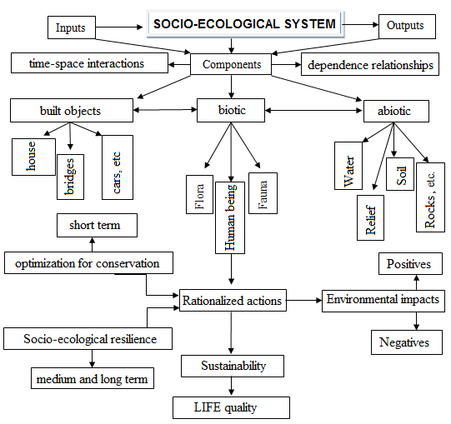
Scheme 3. Example of conceptual map about socio-ecological system and environmental actions.

STEP 4: Analysis of the socio-environmental configuration of the school.
Objective: to identify the main components and some relationships in the scholar environment.
Durations: 3 lectures of 50 minutes each.
Development: The components and relationships in the socio-ecological system of the scholar environment should be annotated individually. The annotations should be evaluated to verify if the learning was effective and if students indicate built and social elements together with the ecological ones as the environment (duration: about 40 minutes).
Students in the classroom should be divided in groups of 4 components and the results of each group should be compiled (duration: 15 minutes).
A table in the board should organise the elements and relationships indicated by the students, in order to share the results (duration: about 25 minutes).
Based on the environmental complexity, a discussion should be initiated about the necessity of the environmental conservation and socio-ecological resilience. The educator and students should reflect on which actions inside and outside the school could be performed to conserve better the local socio-ecological system (duration: about 20 minutes).
The students should be asked to produce an individual text describing what was observed and discussed (duration: about 50 minutes).
Evaluation activity: Annotations and development of the proposed activities.
Preparation of the following lecture: Ask students to search for environmental actions that have been made in the town, in the country or any part of the planet.

STEP 5: Analysis of the environmental actions and projection of the future.
Objective: To analyse examples of environmental actions which have been developed, classify them as socio-ecological resilience or optimisation for conservation types, and propose actions to be developed in the school.
Duration: 2 lectures of 50 minutes each.
Development: The searched results should be orally shared (duration: about 30 minutes).
The actions searched should be classified as socio-ecological resilience or optimisation for conservation types (duration: about 20 minutes).
A hypothesis about the future panorama for the local, regional or global socio-ecological system should be discussed (duration: about 50 minutes).
Evaluation activity: An individual proposal of the environmental action to be developed in the school should be planned at home.

STEP 6: Analysis of the proposals of environmental actions.
Objective: to analyse the environmental actions and, in group, choose those more appropriate to be developed.
Duration: 2 lectures of 50 minutes each.
Development: The proposals should be orally shared (duration: about 50 minutes).
The viability, necessity and importance of the proposals should be discussed (duration: about 30 minutes).
One or more proposals should be selected to be developed in the school (duration: about 20 minutes).
Evaluation activity: Participation in activities inside the classroom.
Some examples of conservationist actions include: separation of the waste produced in the school for recycling; give preference to use biodegradable materials to produce scholar activities; to promote campaigns for the rational use of water in the school; actions to conserve trees in the school and surroundings; looking for better ways to take care of gardens or green space of the school; improve the foresting inside and outside the school; elaboration of educational posters, leaflets and manuals about environmental themes; create rules on how coexist to better socially in the school; strategies to improve the coexistence between students/employees and the fauna in the school as well as the surroundings; to cultivate organic vegetables to complement the scholar lunch; to organize discussions in order to promote actions on behalf of the conservation in the school and surroundings, etc.

